**Lesion-Aware Explainability Validation for Apple Disease CNN**

**Report Analysis**

**1. Introduction**

Deep learning, especially Convolutional Neural Networks (CNNs), has shown great success in classifying plant diseases from leaf images. It's unclear if these algorithms' predictions are based on the disease lesions themselves or on extraneous areas like backdrop texturing because they frequently function as "black boxes." Such a lack of interpretability in agriculture can result in decisions that are not trustworthy.

In order to visualize which areas of an image the model concentrates on during prediction, explainability techniques such as Grad-CAM are utilized. These heatmaps are helpful, however they are frequently assessed visually, which is arbitrary and devoid of scientific validity.

In this study, we propose a quantitative explainability pipeline to validate whether the model’s attention aligns with actual lesion areas. We use Grad-CAM to generate heatmaps for predictions made by both a pretrained and a fine-tuned ResNet-50 model. These heatmaps are binarized and compared with ground-truth binary lesion masks using the Intersection over Union (IoU) metric.

This helps assess not just model accuracy, but also whether the model truly "understands" and localizes the disease.

**2. Methods Used**

This study utilizes the ResNet-50 CNN architecture to classify apple leaf diseases and validate whether the model's attention aligns with actual lesion regions. Two model variants were evaluated with a threshold of 0.5 as follows:

* **Pretrained ResNet-50:** Used as-is with ImageNet weights for general feature extraction.
* **Fine-tuned ResNet-50:** Trained further on the apple leaf disease dataset, with 143 layers frozen and a learning rate of 1e‑4, to better adapt the model to domain-specific lesion patterns.

**Preprocessing & Validation Logic**

Each input image undergoes the following processing steps:

1. Image loading and resizing to the standard input shape of 224×224.
2. Prediction is made using the classification model, and the predicted class index is extracted.
3. Grad-CAM heatmap is generated using the predicted class index and the last convolutional and classifier layers.
4. The heatmap is resized to 224×224, then binarized using a fixed threshold of 0.5 to create a binary attention mask.
5. A ground-truth lesion mask is loaded from disk, or generated if missing, and resized if needed to match the model’s input dimensions.
6. The IoU score is computed between the Grad-CAM binary mask and the ground-truth lesion mask.

All images and their corresponding results (original, lesion mask, Grad-CAM, binarized CAM, and IoU) are visualized side-by-side for inspection. The function is modular, allowing reproducible, image-by-image evaluation across both model variants.

This end-to-end logic guarantees a consistent, quantitative comparison of model emphasis and serves as the foundation for the explainability validation process.

**3. Results**

To evaluate the model's attention alignment with disease lesions, we implemented the explainability pipeline on a subset of images from a Kaggle-based apple leaf disease dataset, originally consisting of 1,743 images. Due to the high computational cost of Grad-CAM generation and IoU calculation, a representative sample of the dataset was selected for both the pretrained and fine-tuned models following an equal distribution of classes.

* For the pretrained ResNet-50 model, 60 images were used:
  + 20 images each from three classes: Healthy, Rust, and Scab (10 from each class shown in the report).
* For the fine-tuned ResNet-50 model, 300 images were used:
  + 100 images per class (Healthy, Rust, Scab), with 10 per class included in the report for display purposes.

The fine-tuning process involved:

* Freezing the first 143 layers of the ResNet-50 architecture.
* Training the remaining layers using a learning rate of 1e‑4 to adapt the model to apple leaf disease features.

For each selected image, the pipeline produced the following:

* Original RGB image
* Ground-truth binary lesion mask
* Grad-CAM heatmap
* Binarized Grad-CAM mask
* IoU score between the binarized Grad-CAM map and the ground truth lesion mask

**Results for pre-trained ResNet50 model**

1.scab_4.viz  
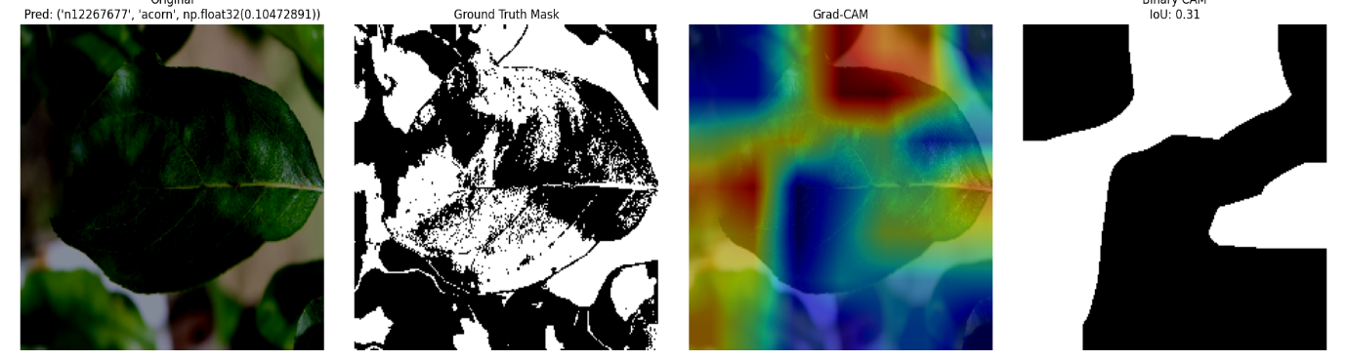

2. scab_12.viz

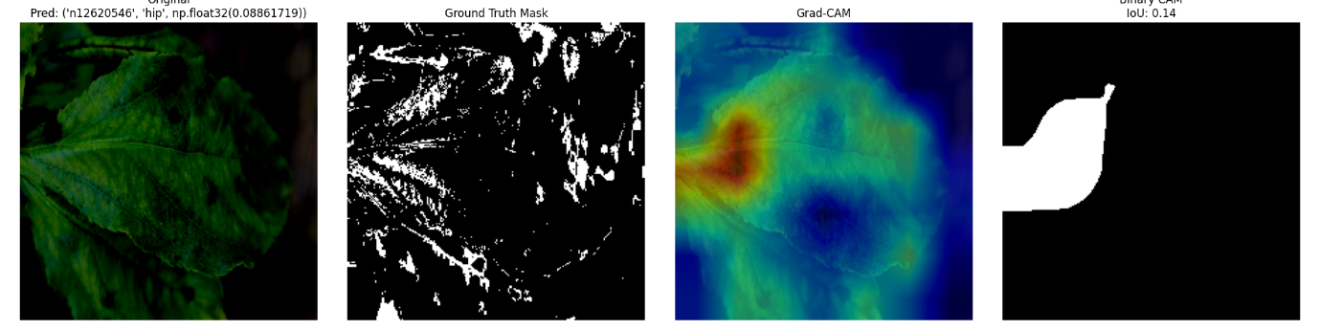

3. scab_14.viz

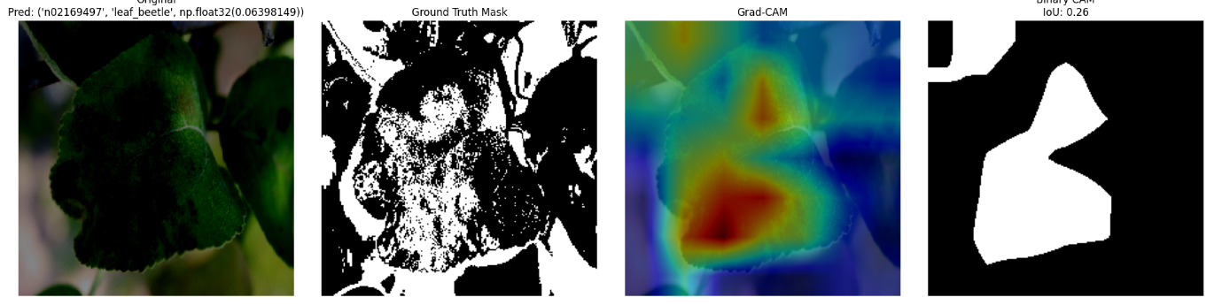

4. rust_1.viz

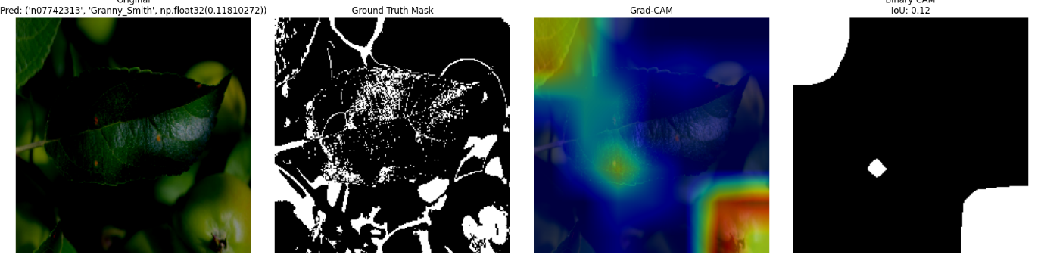

5. rust_10.viz

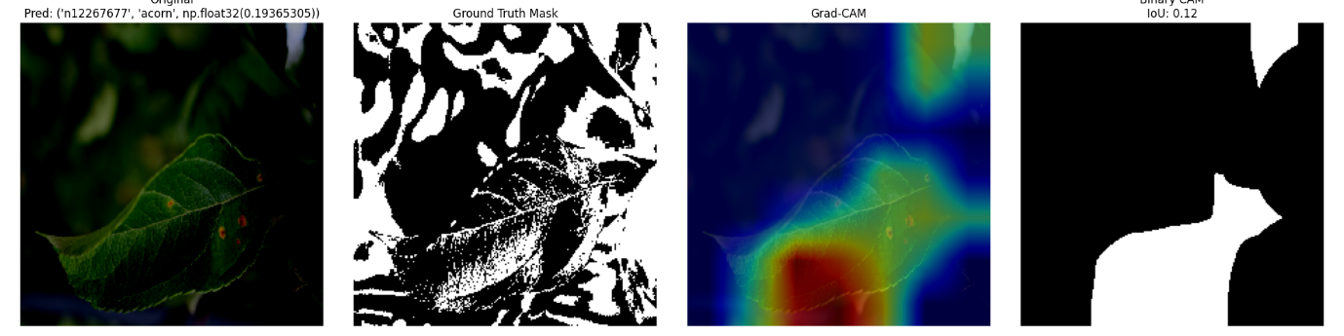

6. rust_12.viz

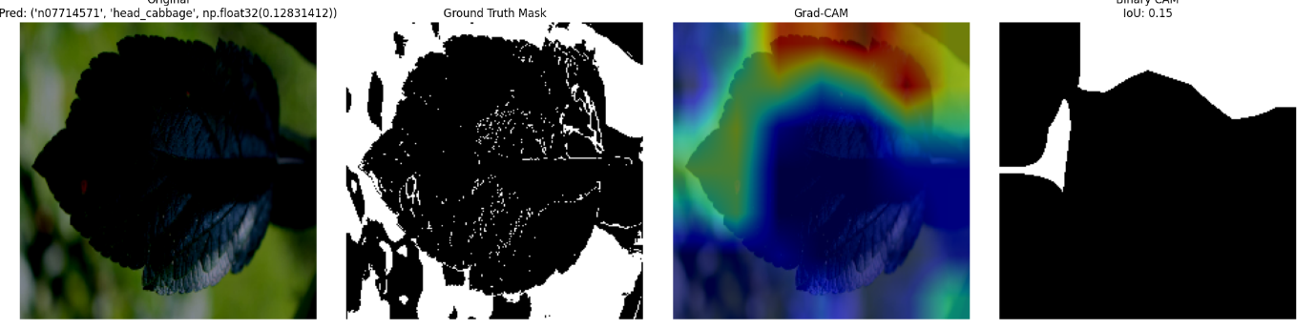

7. rust_19.viz

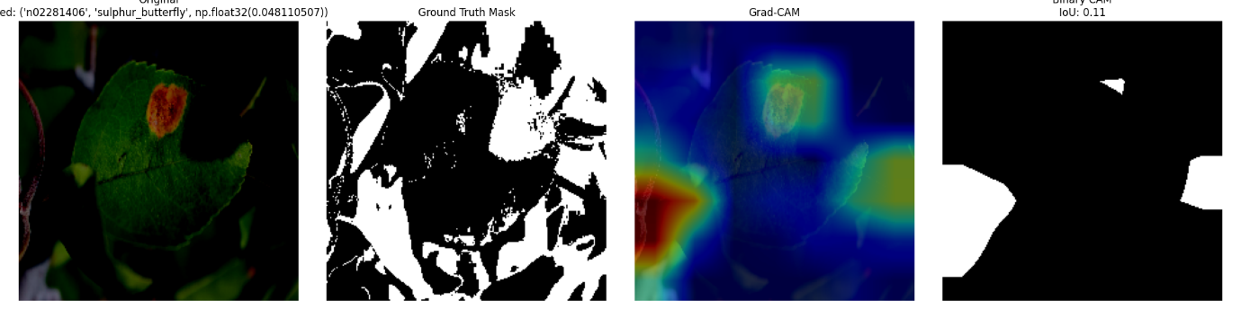

8. healthy_12.viz

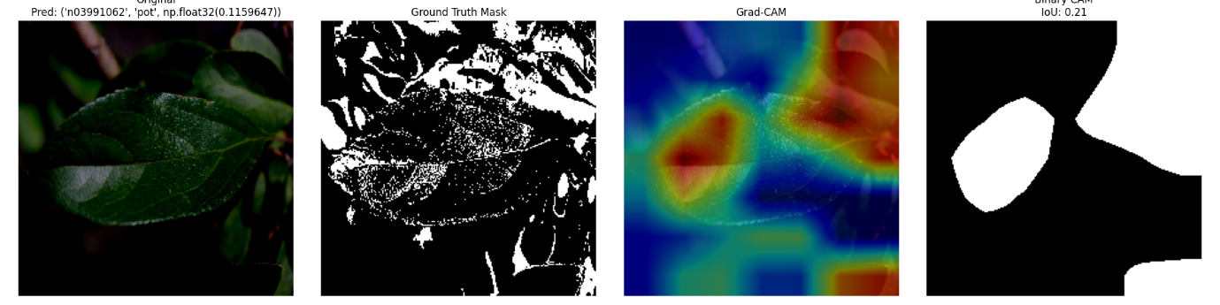

9. healthy_14.viz

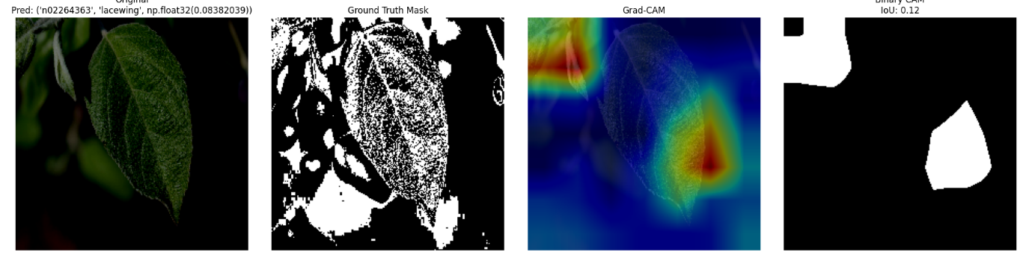

10. healthy_16.viz

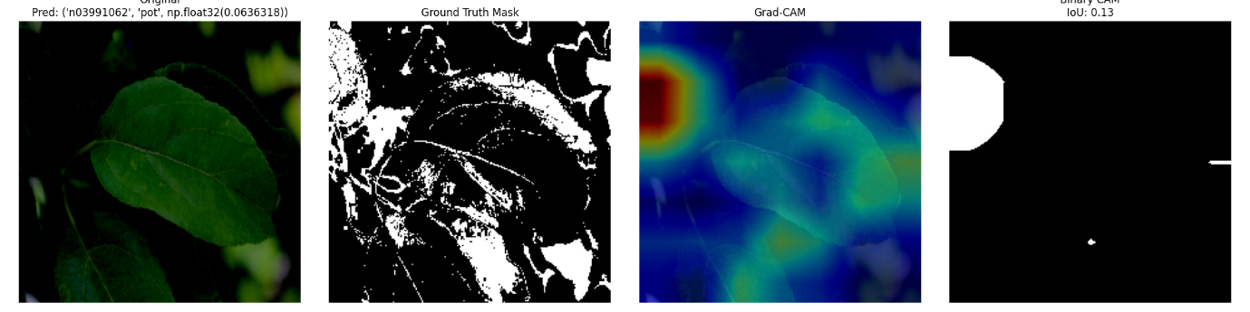

**Results for fine-tuned ResNet50 model**

1. scab_40.viz

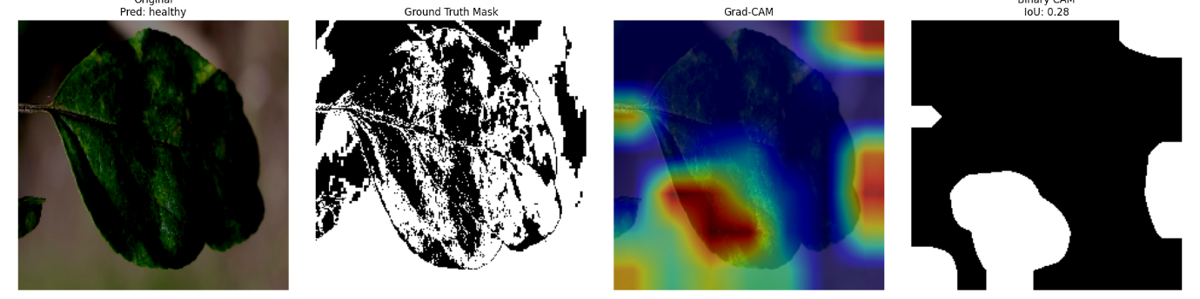

2.scab_66.viz

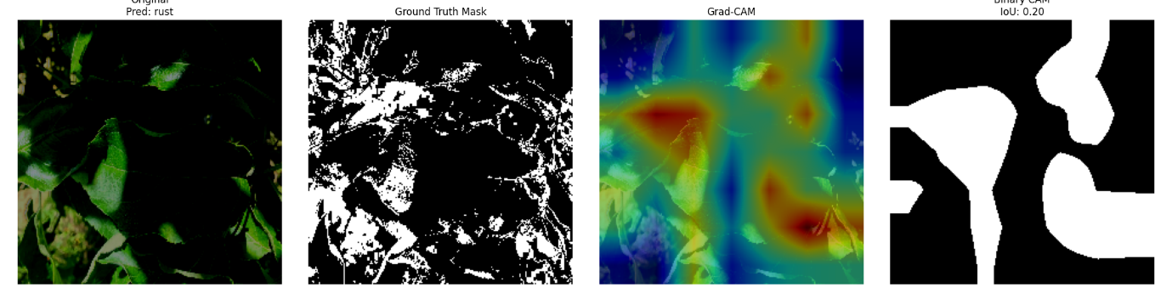

3.scab_74.viz

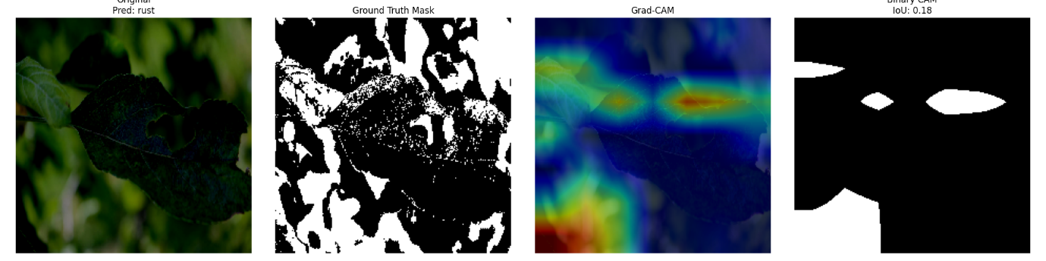

4. rust_7.viz

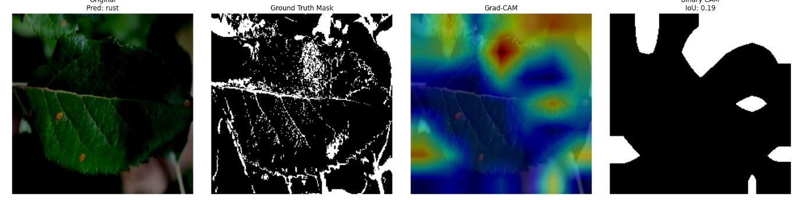

5. rust_16.viz

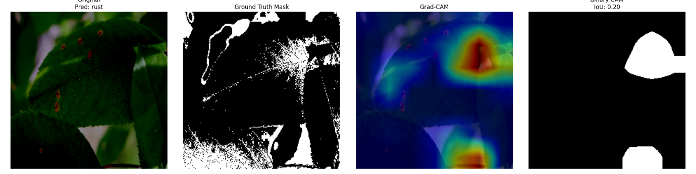

6.rust_76.viz

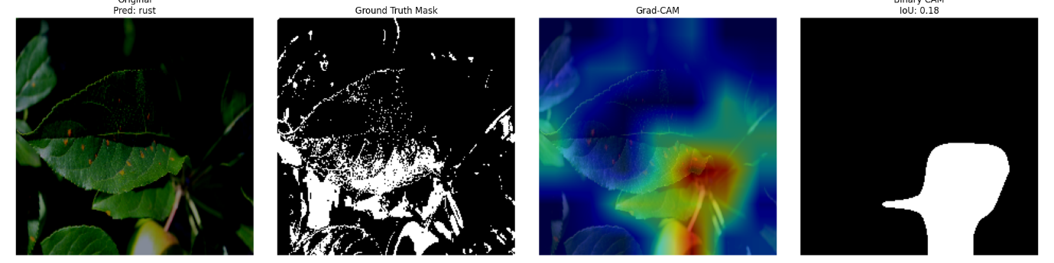

7. rust_99.viz

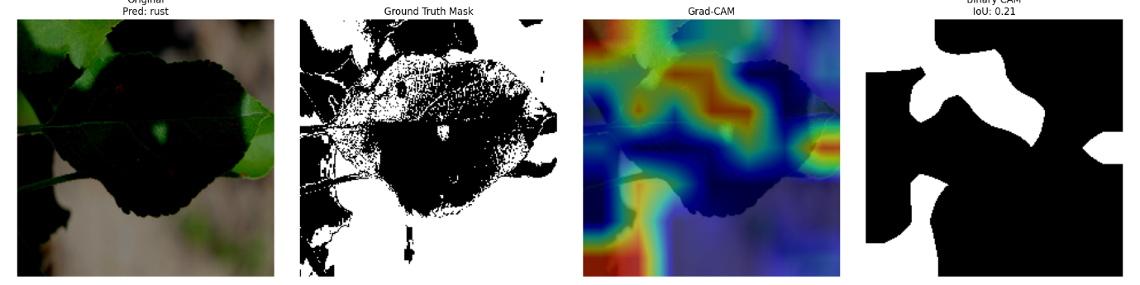

8. healthy_12.viz

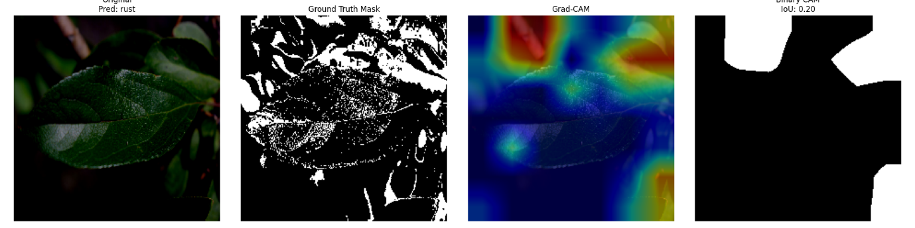

9. healthy_13.viz

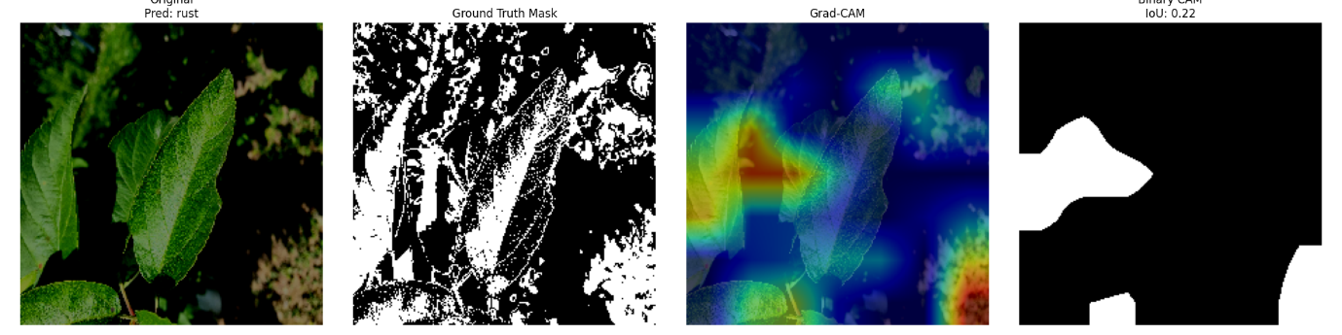

10. healthy_42.viz

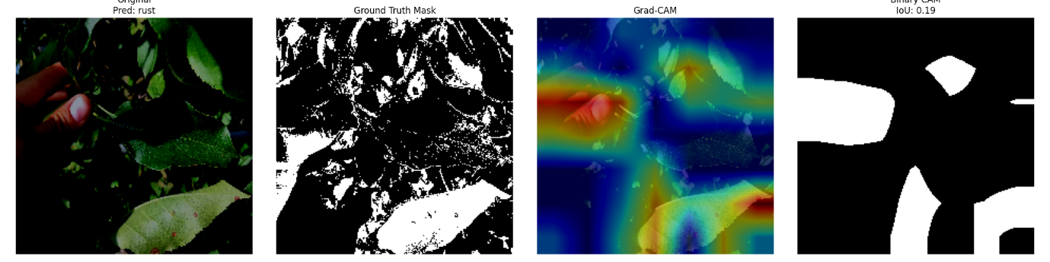

An attempt to compute the IoU scores using the Grad-CAM++ and Score-CAM metrics was made but due to computational overhead, only one visualization was generated as follows:

1. healthy_70_xai

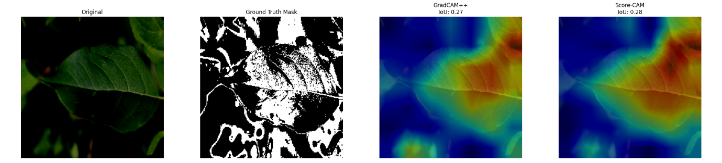

**IoU Score Summary**

|  |  |
| --- | --- |
| **Model Variant** | **Average IoU Score** |
| Pre-trained ResNet-50 | 0.0823 |
| Fine-tuned ResNet-50 | 0.0739 |

**Interpretation**

As seen by the low average IoU scores, the results clearly show that both models did not perform well in localizing actual lesion locations. The model's attention stayed somewhat in line with the ground-truth lesions in spite of the fine-tuning effort. The pretrained model performed better than the fine-tuned version, indicating that the model might have become more focused on high-level class features rather than low-level lesion textures as a result of fine-tuning.

The report supports this analysis with all per-image visualizations, comparisons, and IoU scores for 10 photos per model.

**4. Insights**

The pretrained model's and the fine-tuned model's low average IoU scores: 0.0823 and 0.0739, respectively, show that neither model was able to adequately concentrate on actual disease lesions. The Grad-CAM attention maps hardly ever matched ground-truth lesion regions, even when classifications were accurate.

This result was influenced by several important factors:

1. Rather than concentrating on lesion regions directly, CNNs may rely on background texturing or the general form of the leaf because they are designed for classification rather than localization.
2. Class-discriminative areas, which don't necessarily match lesions, are highlighted by Grad-CAM. The sick area is not the only consistent visual feature that may be used in the model.
3. Its even lower IoU score can be explained by fine-tuning, which can lead to overfitting to class-level abstractions and less attention to fine lesion-level features.
4. Heatmaps' fixed thresholding limits their adaptability. Binary attention masks that are more accurate may be produced via adaptive techniques (such as Otsu or percentile).

The IoU benchmarks of 0.486 (threshold = 0.5) and 0.282 (threshold = 0.75), as stated in this [MDPI paper](https://www.mdpi.com/2071-1050/14/3/1458), were noticeably higher than our findings. Their performance, however, was predicated on bigger datasets and perhaps higher resolution (e.g., 448×448). We may have hampered the model's capacity to learn robust spatial characteristics by using a downscaled resolution of 224×224 and a dataset of only 300 photos.

Although results are still variable and model-specific, investigating Grad-CAM from earlier layers (closer to the input) may provide better lesion-level attention.

These results demonstrate that great accuracy does not necessarily indicate trustworthy attention, and additional study is required to create more dependable and understandable models for practical agricultural applications.

**5. Conclusion**

Using Grad-CAM and Intersection over Union (IoU) as the primary assessment metric, this study proposed a lesion-aware explainability validation methodology for CNN-based apple disease classification. We went beyond merely evaluating classification accuracy to determine how well the machine "understands" the disease by contrasting its attention with real lesion locations in binary segmentation masks.

Pretrained on ImageNet and fine-tuned on photos of apple disease, two ResNet-50 models were assessed. Remarkably, both models had poor lesion localization performance, with average IoU scores of 0.0739 (fine-tuned) and 0.0823 (pretrained). This demonstrated that even accurate predictions could be derived from characteristics that are not exclusive to the disease region.

These results emphasize how crucial it is to statistically validate explainability outputs, particularly in crucial fields like agriculture. Better thresholding strategies, different XAI approaches (such as Grad-CAM++), or integration into models that are concurrently trained for classification and segmentation can all be added to the suggested pipeline.

The foundation for future plant disease models that are more reliable and understandable is laid by this work.